DBMS

Ex–1 DDL Commands

Name:- K. DUSHYANT REDDY Reg No.:- RA1911033010029

Branch:- CSE-SE

AIM:

To implement DDL commands to perform creation of table, alter, drop, modify, rename, truncate and delete column.

COMMANDS:

1. CREATE – When a table is created, its columns are named, data types and sizes are supplied for each column.

Syntax-

CREATE TABLE <table-name> (<column name> <data type>(<size>), …);

CODE-

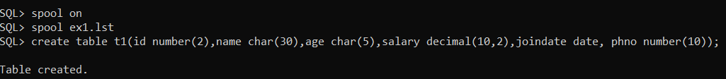

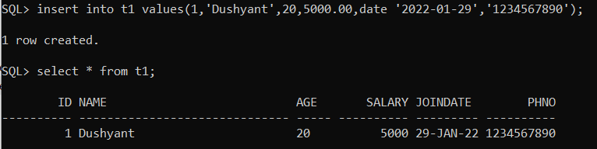

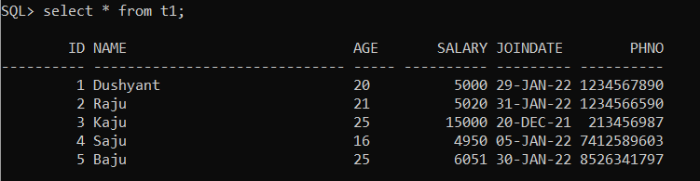

1. ALTER – Used to change definitions of existing tables.

Syntax-

ALTER TABLE <table-name> ADD <column name> <data type><size> [<constraint name>];

CODE-

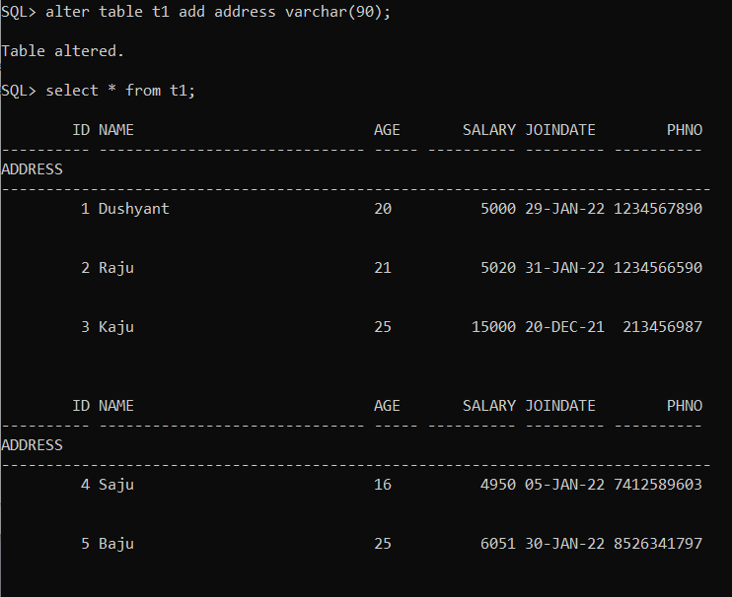

1. MODIFY – Used to modify existing columns of tables.

Syntax-

ALTER TABLE <table-name> MODIFY <column name> <data type><size> [<constraint name>];

CODE-

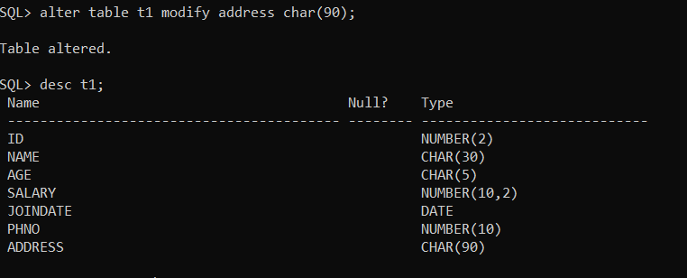

1. RENAME – Used to change the name of tables.

Syntax-

RENAME <old-table-name> TO <new-table-name>;

CODE-

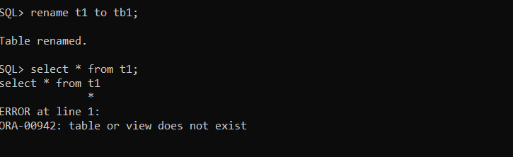

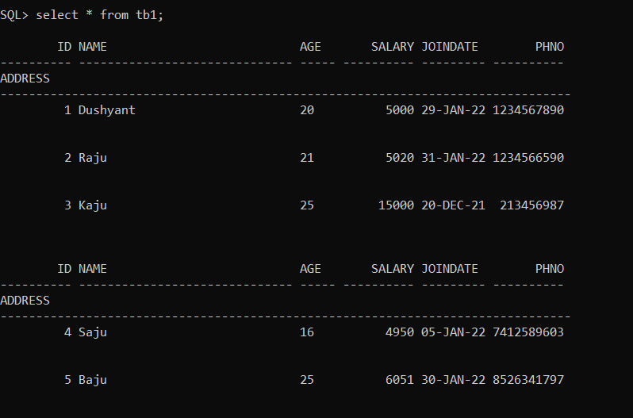

1. DELETE – Used to delete rows from the table.

Syntax-

DELETE FROM <table-name> WHERE <condition>;

CODE-

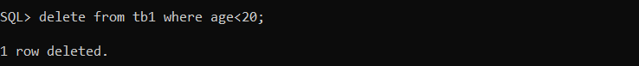

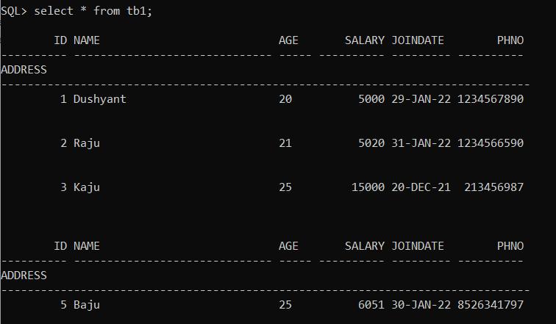

1. TRUNCATE – Used to remove complete data from the table.

Syntax-

TRUNCATE TABLE <table-name>;

CODE-

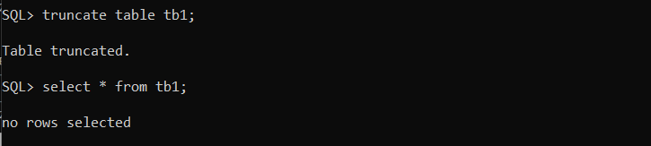

1. DROP – Used to drop the table from database.

Syntax-

DROP TABLE <table-name>;

CODE-

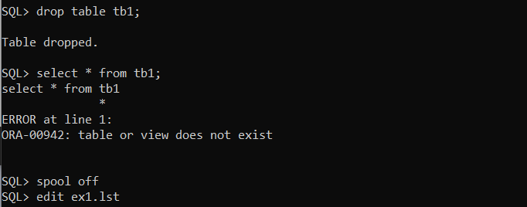

RESULT:

Thus, the DDL commands have been executed successfully